Proposed Auckland Street Character Area Guidelines

Introduction

A Character Area is a collection of houses, streets, or part of a suburb that contains built form characteristics valued by the community. Character Areas can be nominated by members of the public with demonstrated support of at least 40 percent of owners required in the subject area.

Character Area Guidelines (Guidelines) operate by augmenting the R-Codes, which provides two pathways to achieve development approval. There is a prescriptive ‘deemed to comply’ standard and an outcomes based ‘design principle’ and ‘local housing objective’. This provides applicants the ability to propose alternative design solutions that achieve desired outcomes whilst enabling site-responsive developments.

The City has received a nomination for the portion of Auckland Street between Gill Street and Hobart Street. This nomination was supported by 26 landowner signatures of the total of 39 lots representing 66 percent support for a Character Area. As this has met the 40% requirement stipulated by Local Planning Policy: Character Area Guidelines, the City has been progressing the nomination.

Site visits to the nominated street have been undertaken as to understand the character of the streetscape. It is noted that a large proportion of homes on the street being of a Californian Bungalow typology and the streetscape being primarily single storey in nature with large street setbacks. It is also noted that streetscape incorporates a number of contemporary builds, being of one and two storeys in height as well as subdivided lots in a battle-axe configuration.

Elements of the Residential Design Codes that can be modified

The City can modify the deemed-to-comply criteria of the following elements of the R-Codes that are applicable to any character area guidelines:
- Street Setbacks
- Building Height
- Setbacks of Garages and Carports
- Street Surveillance
- Street Walls and Fencing
- Sight Lines

Local housing objectives may be considered for elements that are not provided for by the R Codes. The local housing objectives must align and not contradict existing design principles.

Design Elements

The Built form provisions identified which can aid in enhancing and promoting the character of Auckland Street. These include:

- Maintaining the established ground floor street setbacks.
The City can look to ensure that the deemed-to-comply requirement maintain the established ground floor street setback.

- Ensuring that second-storey development is adequately setback from the street as to maintain the single-storey streetscape.
This portion of Auckland Street is predominantly single storey. To aid in maintaining this streetscape, the City could require that second storey development is located further from the predominant building line than currently required by the Built Form Policy (2 metres). For example, existing character area guidelines require that second storeys be located behind the ground floor ridgeline (as shown in the image below).

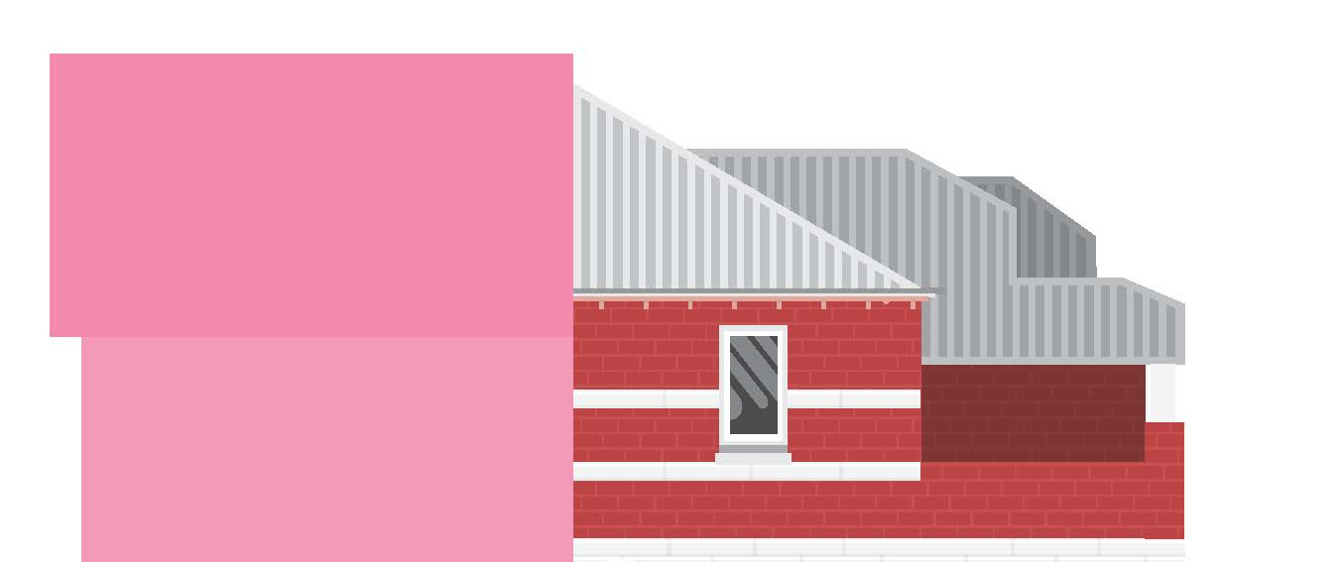

- Design and setbacks of carports and garages
The Built Form Policy requires that carports and garages be located behind a dwellings predominant building line. This is to minimise the impact of car parking structures on the streetscape. Additional provisions could be to ensure that car parking structures are of similar design to the existing dwelling.

- General Building Design elements
Existing character area guidelines have additional requirements which seek to help maintain the existing streetscape. These include provisions such as roof pitch, materiality, window sizing and shape and requirements for verandahs. Noting the prevalence of Californian Bungalows along Auckland Street, the City could seek to maintain these through requiring verandahs on new development.

It should be noted that the above are suggestions and items for discussion. The City is seeking suggestions from the community on the elements of Auckland Street that they value. These items could then be considered for future character area guidelines.

Next Steps

Following the street meeting, the City will incorporate suggestions and comments into a draft character area guideline for Auckland Street. It is suggested that a working group be created to discuss the draft guidelines with this group, with the intention of taking the draft guidelines to Council for endorsement to formally advertise.

Frequently Asked Questions

What is a Character Area?
A Character Area refers to a defined area, whether a suburb, street or groups of lots which has a particular characteristic and cohesiveness worthy of retention or enhancement. A Character Area is only established once it is formally included in Local Planning Policy: Character Area Guidelines.

What does 40% support of nomination mean?
The City requires a Character Area nomination to be supported by a minimum of 40% of owners in the nominated area to start the process. This helps the City know there is initial interest from the community before commencing community engagement. 40% support is not required for final adoption of Character Area guidelines - this will be determined by Council taking into consideration all submissions received during a subsequent formal advertising period.

What rules apply in a Character Area?
It's different for each area depending on which character or architectural elements are significant. The guidelines developed for Character Areas ensure that new development will be sympathetic to the character of the streetscape and provide guidance to landowners on how to adapt character homes to modern living without negatively affecting the character of the area (as viewed from the street).

What if I want to subdivide my block or demolish the current dwelling?
Being in a Character Retention Area does not impact your ability to subdivide or develop your property – this is purely dependant on the zoning and coding of your lot. Character Areas cannot prevent demolition of a dwelling, only a heritage listing can prevent this. New development, however, is to comply with the approved guidelines.

How are the character area guidelines created?
After first asking the community what aspects of their streets are most valuable, the City will prepare draft guidelines to reflect these views. These guidelines will be worked through with Working Group consisting of representatives from the street to ensure that they align with the community’s views. This will then be taken to a Council meeting for endorsement to advertise. Following the consultation period, the guidelines will be presented to Council for a determination to approve, modify or refuse. Any comments received during consultation will be presented to Council.

Where can I view the relevant policy for this nomination?
The current policy, Local Planning Policy: Character Area can be found on the City’s website under Develop & Build – Planning Forms, Checklists, Policies & Information Sheets – Local Planning Policies.

Do you have any more questions?

If you have any further questions, do not hesitate to contact the project officer via the details below,

- Project Officer: Michael Flanagan, Strategic Planner
- Email: Michael.flanagan@vincent.wa.gov.au
- Phone: 9273 6068

