Examples of Safe Active Street Treatments

The following examples of safe active street treatments are all in Perth suburbs:

Applecross
Intersection of Macrae Road and Gairloch Street
Previously a standard four-way intersection, two new cul-de-sacs were created on Macrae Road with separate paths for walking and cycling passing through.

Macrae Road runs parallel to Canning Highway and had become a rat-run for drivers trying to avoid traffic lights. This change resulted in quieter streets and a much safer route for people riding bikes. Additional tree planting also increased amenity.

Before (2015) After (2021)
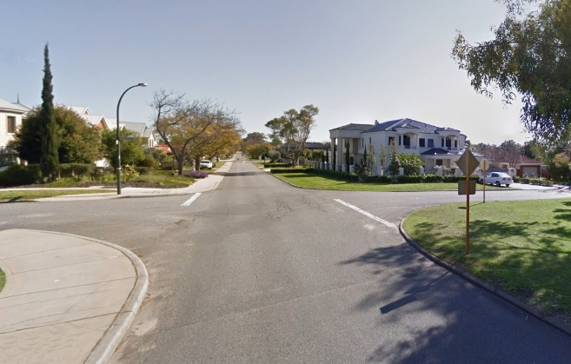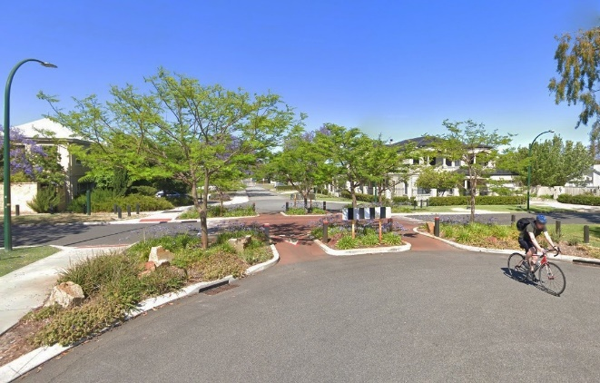

A raised platform and change in surface colour were also added across the intersection which helps to slow motor vehicle traffic approaching along Gairloch Street.

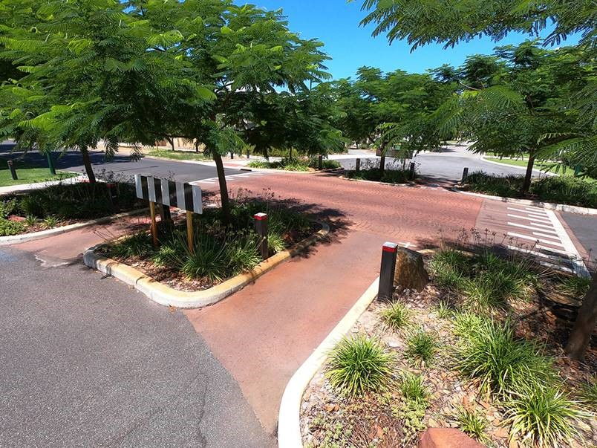

O’Connor
Intersection of Clarke Street and Hines Road
Previously a T-junction with busy road, a cul-de-sac with a small park was created on Clarke Street. The intersection at Hines Road was near the crest of a hill which resulted in increased risk of crashes. This change improved safety for everyone and provided more recreation space. A path through the park ensured the street remained open to Hines Road for people walking and riding.

This example has been in place for about 20 years. It demonstrates how changing an intersection and relocating street space for people can give immediate safety benefits, but also provides an opportunity to increase community amenity over time as funds become available.

This small park at the end of a cul-de-sac now has play equipment, a shelter, picnic table and benches plus a tiny library provided by the local community.

The number of facilities in this example exceed what can be provided by implementation phase of a Safe Active Street, but it can help stimulate our imagination for how our streets can be better in a few years’ time with thoughtful planning.

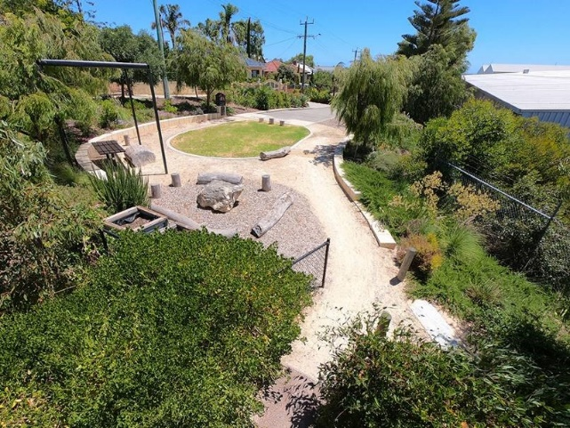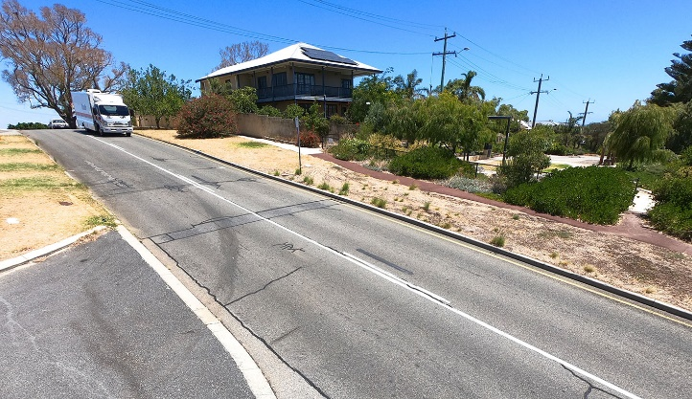

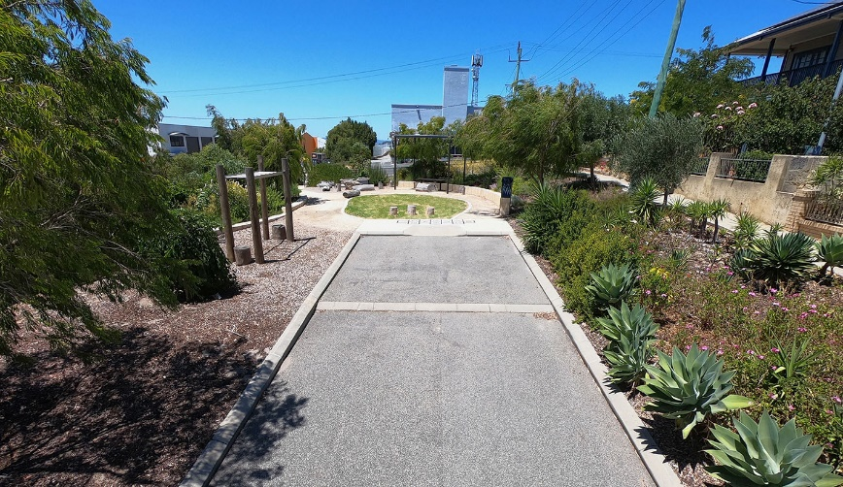

Rivervale
Copley Park (previously Copley Road)
This fantastic street transformation began in 1975. It was once a conventional asphalt street with two lanes for motor vehicles, grass verges, no footpaths, and no trees.

The first step was to increase the amount of green space and reduce the width of the paved area.

Access by car was limited to residents and visitors by installing mid-block bollards. Trees were planted and garden beds introduced. The street became more like a park. Residents can reach their garages by paths gently winding between the trees.

Four of the intersecting streets were made into cul-de-sacs, but people walking and riding have no restrictions. There are shared paths connecting all streets. There are no kerbs, the rain can simply run off the street's paving to help the gardens.

This is a mature example of good street design. It's been gradually improved over 45 years and is now considered a park by most people even though cars are still permitted.

The basic principles used in the design of this street can be applied to Safe Active Streets.

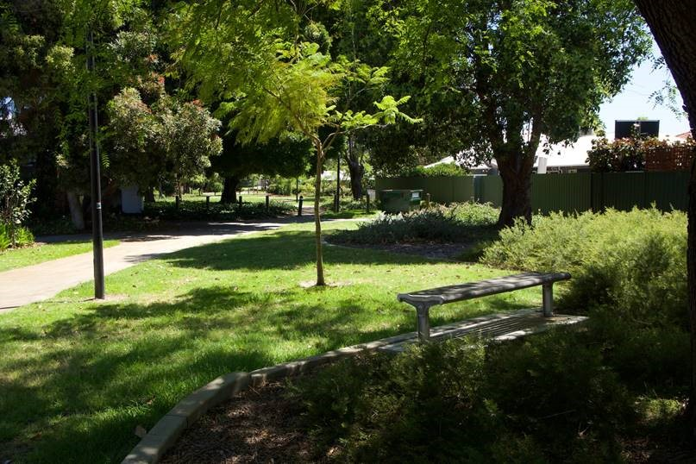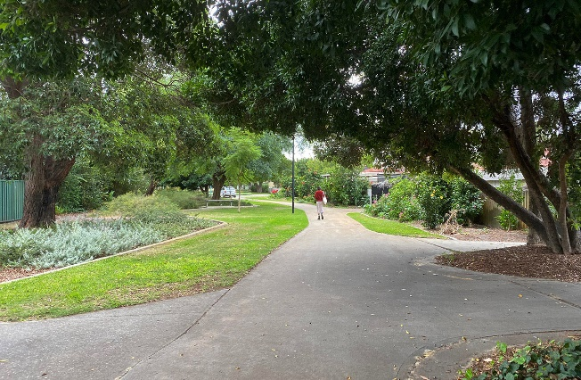

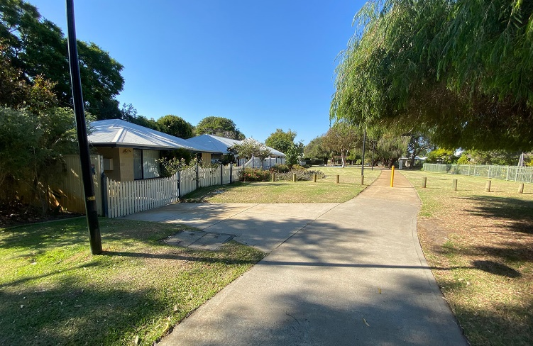

Shenton Park
Keightly Road West
This diagonal diversion was constructed at the intersection of Keightly Road West and Rosalie Street in the late 1980s. The standard footpaths have been retained on both sides of each street. People riding bikes can pass through a convenient central ramp easily.

A second diagonal diversion can also be found one block to the west at the intersection of Keightly Road West and Hensman Road. The combination of these two devices has the effect of reducing rat-running drivers through the area, lowering speed, and making the intersections much safer. The extension of garden beds and additional trees add to the amenity.

This is a successful design. Keightly Road West is a popular route for people walking and riding bikes and the street will soon be included in a new Safe Active Street route across Shenton Park.

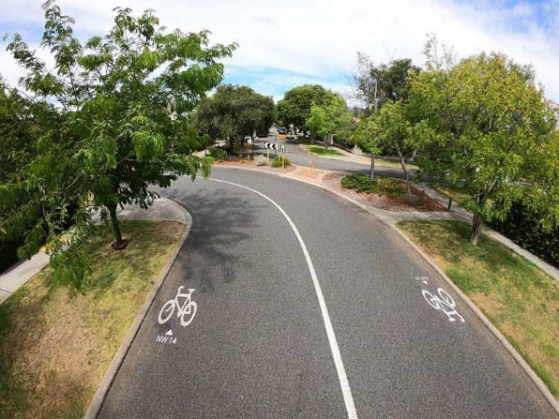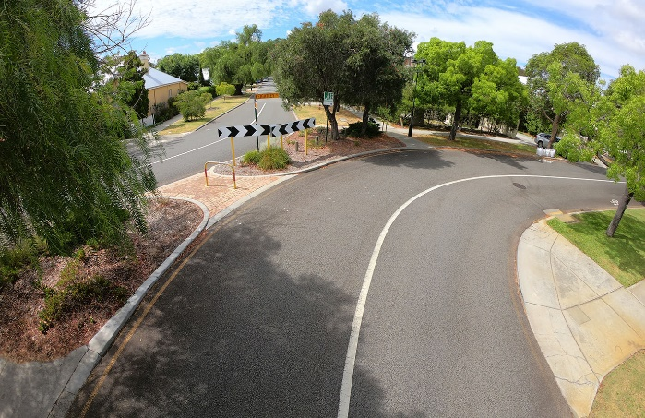

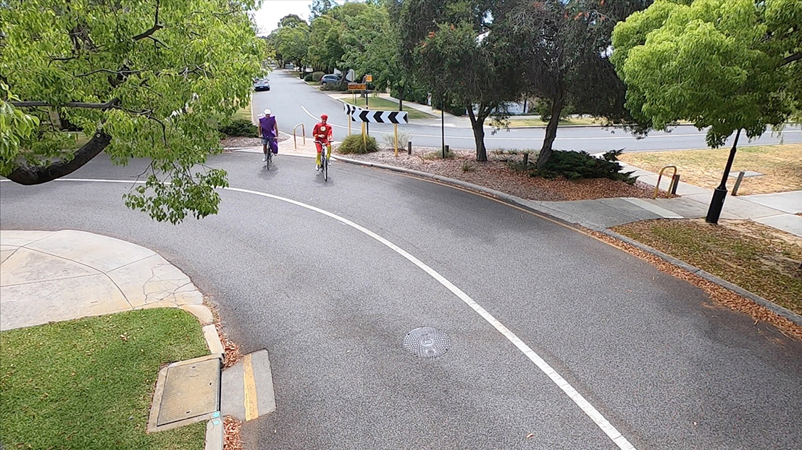

Doubleview
Moorland Street
Narrowing of street to reduce speeding. This gives additional space to plant trees that will be able to grow with less restrictions from power lines. This example is part of City of Stirling's Moorland Street Safe Active Street.

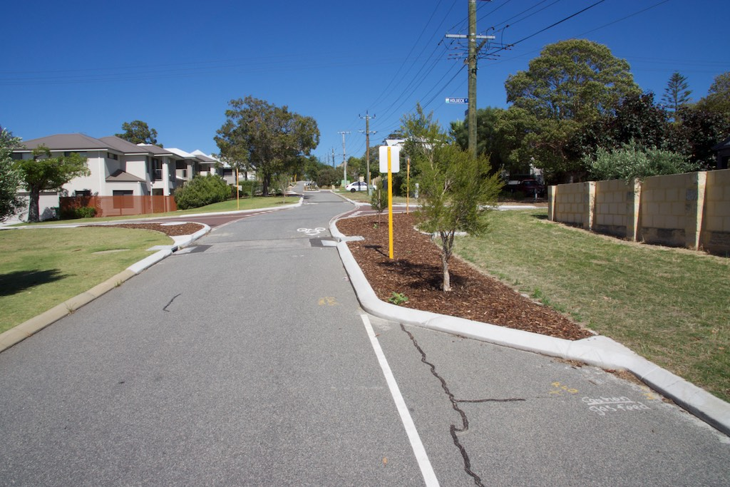
Nedlands
Elizabeth Street
Raised platform across intersection improves pedestrian amenity by creating a flatter street crossing. Motor traffic is slowed before entering the intersection reducing the crash risk.

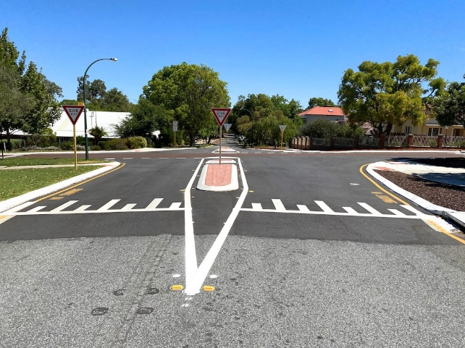

Bayswater
Leake Street
Road humps can be used to reduce motor vehicle speeds. These can be used at the approach to intersections or mid-block.

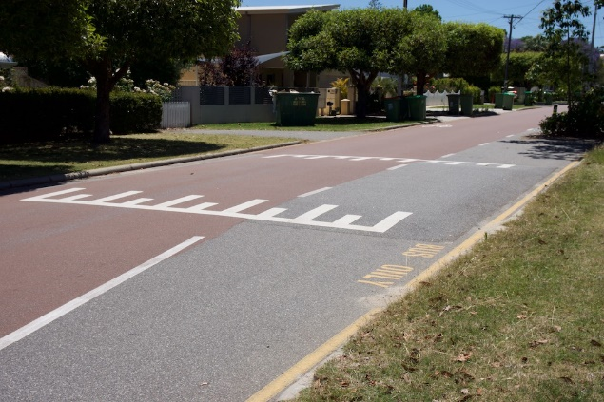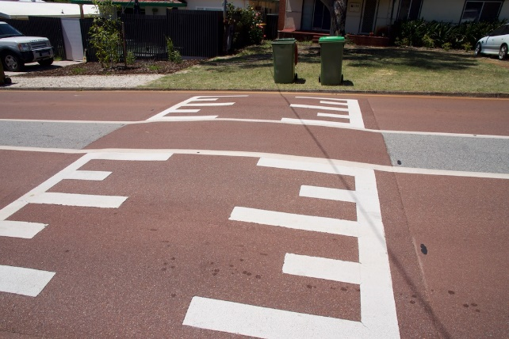

Perth
Palmerston Street
One lane slow point with centre hump, safe by-passes for cyclists plus additional vegetation.

